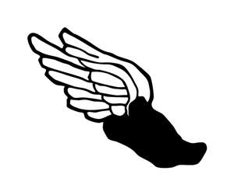
Cresskill Indoor Track

START DATE: WEDNESDAY, NOVEMBER 28th

GOAL: Get into shape while minimizing risk of injury or strains. We use this season to maintain our fitness levels and to compete at a high level in select meets.

Practice is four days a week (Monday through Friday). Practice is mandatory. If you don’t plan on being here all the time, don’t expect to compete in the meets.

Expect to go outside as much as weather permits. Bring clothing that is appropriate for going outside in cold temperatures. We plan on using the track for as long as possible.

If you have been with us before, we will be doing light lifting as well. Special events may have different types of practices/workouts. THURSDAYS WILL USUALLY BE EVENT SPECIFIC DAYS – HURDLES/JUMPS/THROWS

Meets:
NJIC League Meet – EVERYONE will compete in this as long as you are at practice.
Monday, January 7th, 2019 from 4PM-END
Armory T&F Foundation; 168th Street, NYC

High Jump/ Shot Put Meets – Garfield High School (only select people)
Saturday, December 22nd – 10AM
Saturday, January 5th – 10AM
Monday, January 21st – 6PM

LJ/TJ/Pole Vault Meets – FDU Campus (select)
Wednesday January 10th &24th – LONG JUMP/POLE VAULT
Wednesday, January 17th & 31st – TRIPLE JUMP/POLE VAULT

Counties (select)
Wednesday, February 13^{h} – 5 PM @ Armory

