CRESSKILL WINTER TRACK Drifit-Longsleeve=- $23 Short sleeve = $17
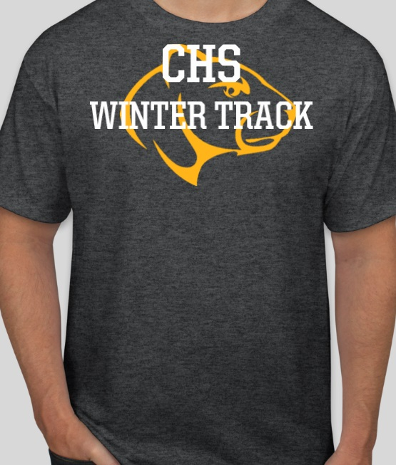
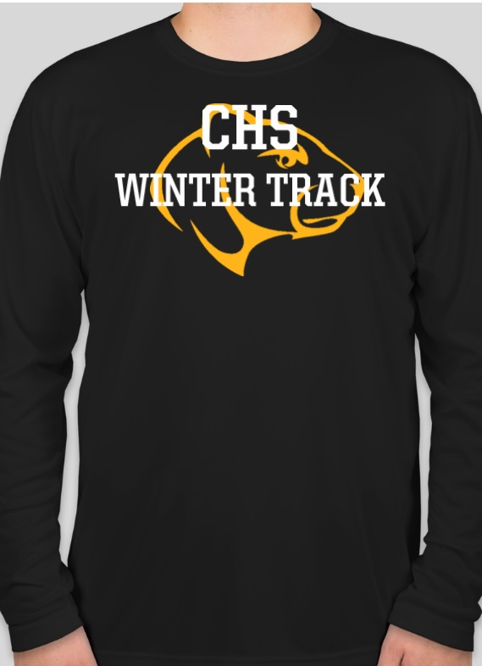
Name _______________________ Phone Number: ______________ Grade _______
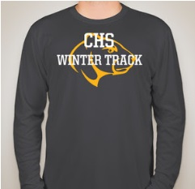

COLOR(Choose): BLACK _____ SLATE GREY_____ COLOR : CHARCOAL HEATHER
ADULT: S___M___L___XL___XXL___
ADULT: S___M___L___XL___XXL___

TOTAL $___________
CHECKS PAYABLE TO CRESSKILL TRACK AND FIELD

