Putting the metric system to Work
Your job is to design a shelving system for our laptops and iPad. Included in this design, we are going to optimize the room we have in our shelving area to allow for any additional laptops and/or iPad we may get in the coming years. Remember, we don’t need the laptops to have big roomy and spacious areas; we are trying to comfortably maximize our space to take laptops in and out.
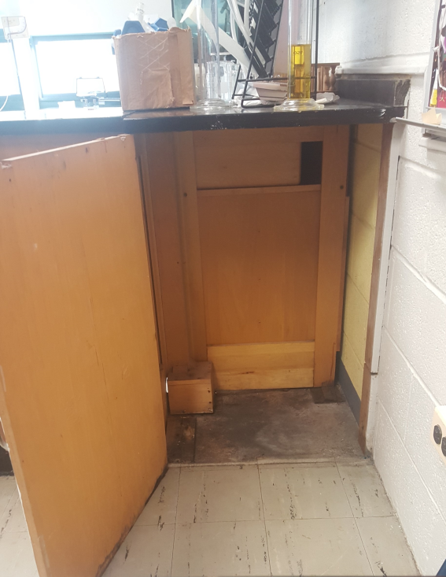
You are going to have to account for how big most pieces of wood are - it wouldn’t make sense to use a 2x4 for this project – they are just too big. Look on a website such as Lowe’s or Home Depot to find out what size wood we should be using as well.
Measurement: Under Cabinet Space

Make sure to measure all areas inside of the cabinet – you are going to need to account for the small blocking pieces on the left side of the shelf.
Your drawing/ Measurements:

Length:
Width:
Height:

Sketch a shelving area as best as you can. Afterwards, make sure to measure all THREE dimensions and add them to your picture.
Measurement: Laptop Dimensions

Length:
Width:
Height:

Sketch a laptop as best as you can. Afterwards, make sure to measure all THREE dimensions and add them to your picture. These laptops are fairly large, so we need to make sure the door can be completely closed!
Measurement: IPad Dimensions

Length:
Width:
Height:

Sketch an IPad as best as you can. Afterwards, make sure to measure all THREE dimensions and add them to your picture.
DESIGN: Come up with a shelving design to maximize the space available. Your design will be graded on the usability of your shelving system and how realistic it is. Remember, we only have 5 iPad and 4 laptops but we need to have room to add more in the future!
In addition to your drawing, you MUST include a written explanation for why you chose sizes/dimensions to make everything fit. If you were going to get paid on how good your design is, what would you include to really sell it?
DRAW YOUR DESIGN WITH MEASUREMENTS BELOW:

