*For questions 1 – 3 consider this circuit*

1. How many pathways are there for electricity to flow through?

Power

Supply

A

B

C

1. Is this a series or parallel circuit?
2. If light bulb A was removed would light bulb B still work? Light bulb C?

*For questions 4 through 7 consider this circuit*

1. How many pathways are there for electricity to flow through?

Power

Supply

A

B

C

1. Is this a series or parallel circuit?
2. If a light bulb A was removed would light bulb B still work? Light bulb C?
3. Would the removal of any light bulb affect the other two?

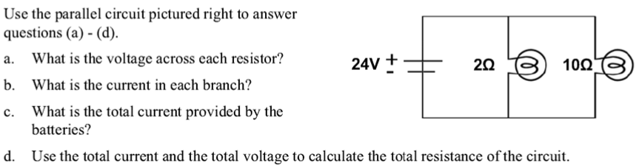

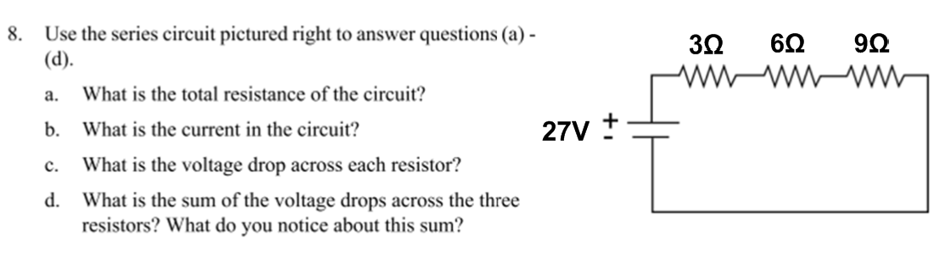

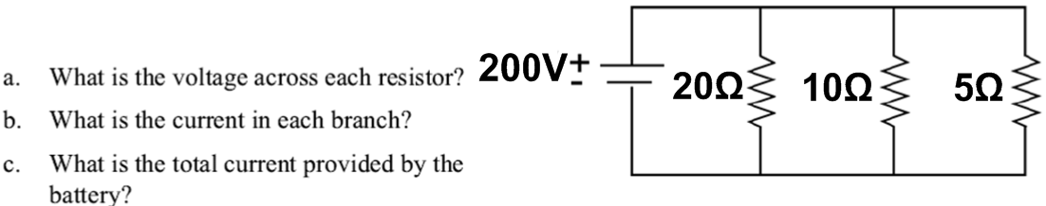

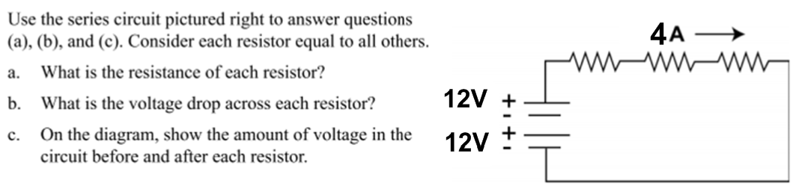

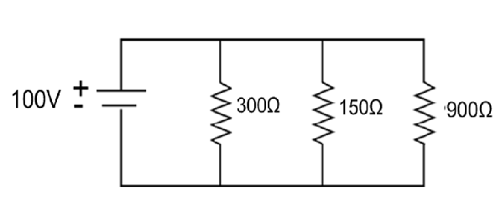

A. Find the TOTAL resistance