Name _______________ Date _______________
Making and Breaking a Magnet
PRE- QUESTIONS – You may not know the answer to some of these right away –COME BACK TO THEM

Why would a train move faster using electromagnets?

Where are magnets the strongest?

Since we know the Aurora Borealis occurs because of magnetism, why do you think it only occurs in 2 places on earth?

___________ ___________- are tiny fields of magnets that normally go ________ _________
When we can organize them in _______ ________ we get _______________
N
N
S
S

DRAW WHAT THESE LOOK LIKE
Unmagnetized Magnetized
Two main categories of magnets
________________ - lose magnetism much easier
________________ - Hard to magnetize but, _______________ ________ for a long time
Permanent Magnets
______________ materials – have strong magnetic properties
Examples : ______________________________________________________
ALNICO is made up of: ___________________________________
- _______ and ______ to make
Most common magnets now are _____________
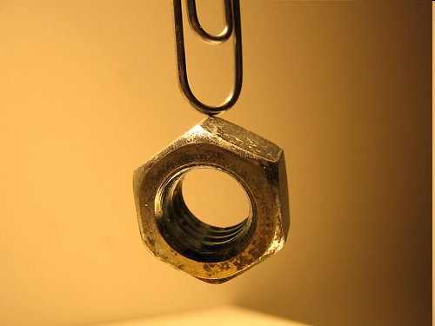
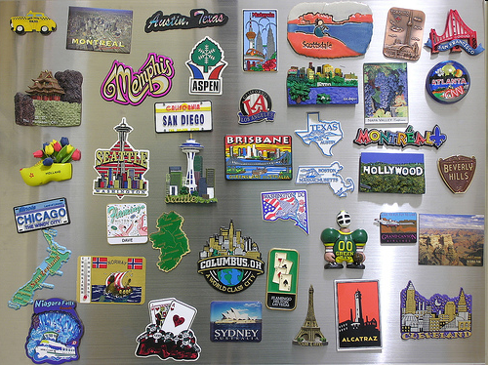

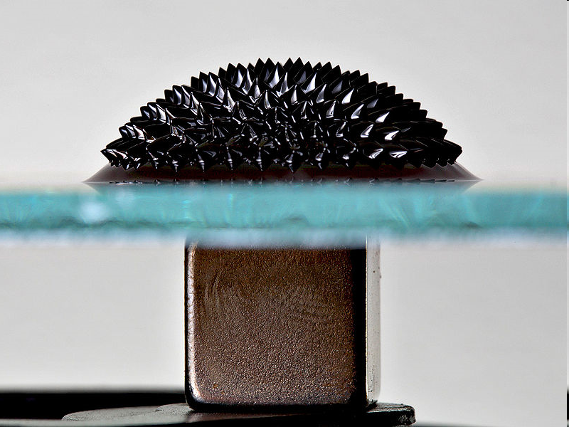

Ferrofluid - ___________ mixed with
__________ ________ that will react to
_________ _________

Making a stronger magnet
The better the domains are _________ - the __________ the magnet
________ _______ are examples of very focused magnets used for a specific purpose
GOOGLE WHAT AN MRI MACHINE DOES AND EXPLAIN BELOW:

