Name _______________ Date _______________
EARTH AS A MAGNET WORKSHEET
PRE- QUESTIONS – You may not know the answer to some of these right away –COME BACK TO THEM
1. Draw the domain of an unmagnetized bar magnet

2. Draw a magnetic field around a bar magnet

3. Design an experiment which would allow you to see a magnetic field.

4. What are the two main categories of magnets? What is different about them?

There are _____ major ways to lose magnetism
- __________________
- __________________
These knock ______________ ____________ out of line.
Magnetic Field lines are ____________ lines the surround ________ _______.
They will ________ ________.
The ___________ the lines are the _______ the force.
The biggest magnet around us is _________________.
As a result it produces magnets from _________________ materials.
Magnetic Declination
-_____________ poles do not always stay put
- ____________ _________ is the movement of these poles
- ____________ POLES MOVE, THE _________ POLES DO NOT
Magnetic Declination is _______________________________________________________________
Secular Variation is ___________________________________________________________________
Solar winds are _______ ______________ particles shooting at Earth
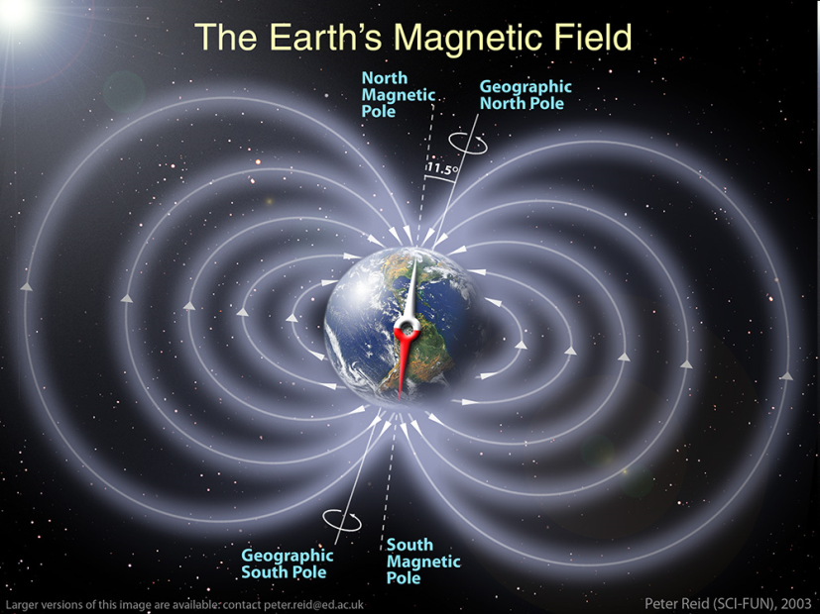
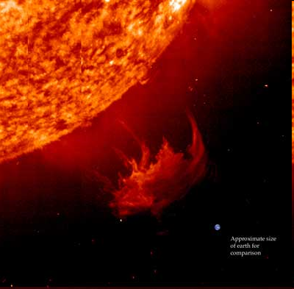
Solar Winds are stopped by Earth’s __________ ____________ _____________
Earth in comparison!

Earth’s Magnetic field is called the _________________
__________ ___________ ____________ - regions on earth of ___________ and ____________ trapped at high speeds.
DRAW THE MAGNETOSPHERE BELOW

