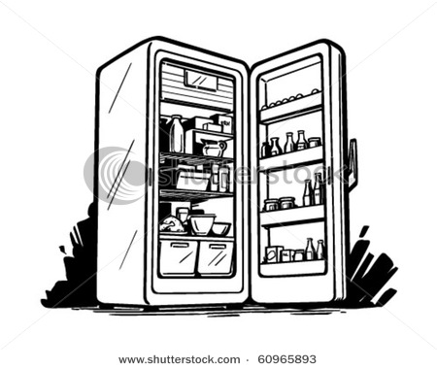
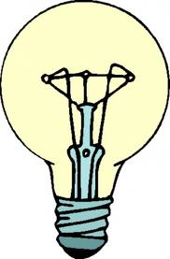
Feats of the Fridge
Have you ever stood in front of the fridge late at night, trying to decide what you want for a midnight snack? As you stand there considering all of that delicious food, have you ever wondered; How does that light bulb stay lit for so long? You’re going to find out.

You and your partner (if you choose) will be working side by side to solve this mystery, figuring out how that tiny light bulb manages to stay lit for so long. Your mission is to design and build a circuit that causes your “mini-fridge” to turn on once you open the door, and turn off once closed.

You can use any materials you need, but your design must be your own (NO PREMADE SWITCHES OR STORE BOUGHT MECHANISMS.) Fridges will be graded based on appearance, design, and most importantly if it works! Designing a fridge from a shoebox isn’t easy, so plan out what materials you need and how you are going to wire your fridge prior to cutting your box. Extra points will be given for creativity, originality and design – the more effort you put in the more points you will get.

Before building your fridge, a variety of materials will be provided in class – light bulbs, light bulb holders and wires. Try and brainstorm and outside items you would want to bring from home, such as tin foil, springs, glue guns or any decorations.

Once your fridge has been built, you must draw a diagram detailing how the wires are connected. On the back of the drawing, make sure to answer the following questions in full sentences. Remember,. This is a final copy and should not have spelling errors, whited out corrections, or half typed half handwritten answers.

- How did you come up with your fridge design?

- What other things could you use your circuit design for? Does anything already use this design?

- List ALL materials used to build your fridge.

- Think of 2 other devices that don’t only turn on or off with a switch. (Think of a design like the fridge with a special purpose, like a light switch that dims lights in addition to turning on and off.)

