Come Fly with Me Lab
QUESTION: How does changing a paper airplane affect how far it will fly?
HYPOTHESIS (is it testable?)______________________________________________________________
__________________________________________________________________________________________________________________________________________________________________________
MATERIALS
3 Paper Airplanes, each different (Can use construction, computer, newspaper, notebook paper) Measuring Tape.
PROCEDURE
Design a procedure with your partner. Number your steps. A final version should be written on the back of this paper.
DATA CHART
You will need to design a chart to organize the data you collect. Your chart needs to include 3 trials (3 planes) and an average for each type of paper. You will also have to make a bar graph of your AVERAGES. A final version should be written on the back of this paper.’
CONCLUSION
Your lab group will have to write a conclusion. Remember that your conclusion must explain your results by referring to your data chart and should help answer your hypothesis. A final version should be written on the back of this paper.
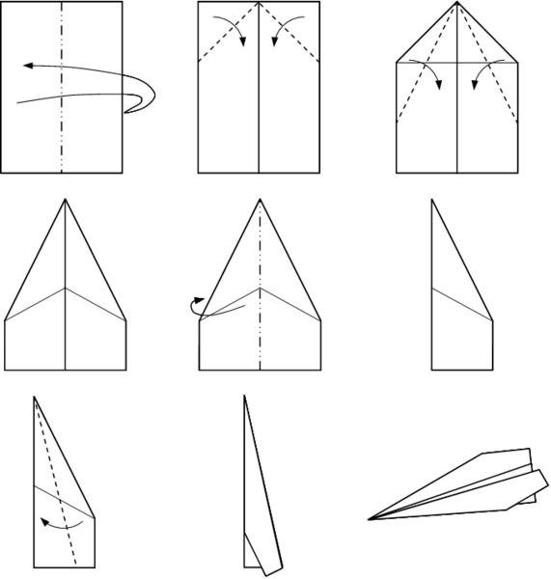
ROUGH DRAFT PROCEDURE:
________________________________________________________________
________________________________________________________________
________________________________________________________________
________________________________________________________________
________________________________________________________________
________________________________________________________________
________________________________________________________________

Come Fly with Me Lab
Hypothesis __________________________________________________________
____________________________________________________________________
Materials: ___________________________________________________________
Procedure: ___________________________________________________________
____________________________________________________________________
____________________________________________________________________
____________________________________________________________________
____________________________________________________________________
Data Chart:
Planes | Trial 1 | Trial 2 | Trial 3 | AVERAGE

Bar Graph:
Key

Conclusion: __________________________________________________________
____________________________________________________________________
____________________________________________________________________
____________________________________________________________________

